DR YSR GVOT DEGREE COLLEGE, VEDURUKUPPAM
National Service Scheme – Unit-1
Swarnandhra Swatchandhra
-----------------------------------------------------------------------------------------------------------------
Theme of January – 2025 : Sanatory Waste management
No of NSS Volunteers participated : 78
No of Teaching and Non-teaching Staff participated :15
Agenda of the Programme:
- Inauguration of Programme
- Oath of Swarnandhra Swatchandhra
- Rally against Zero sanitary and Management
Zero Sanitary Waste and Management refers to minimizing and properly managing waste generated from sanitary products such as pads, tampons, diapers, and other personal hygiene items. These wastes are often non-biodegradable and can harm the environment if not disposed of properly.
The main aim is to reduce the use of single-use sanitary products and promote eco-friendly alternatives. This includes using biodegradable sanitary pads, menstrual cups, and reusable cloth pads. These options help in reducing landfill waste and environmental pollution.
Proper waste management practices include segregation of sanitary waste, safe disposal in designated bins, and the use of incinerators or scientific disposal methods. Awareness programs are also important to educate people, especially in rural areas, about hygiene and environmentally safe disposal methods.
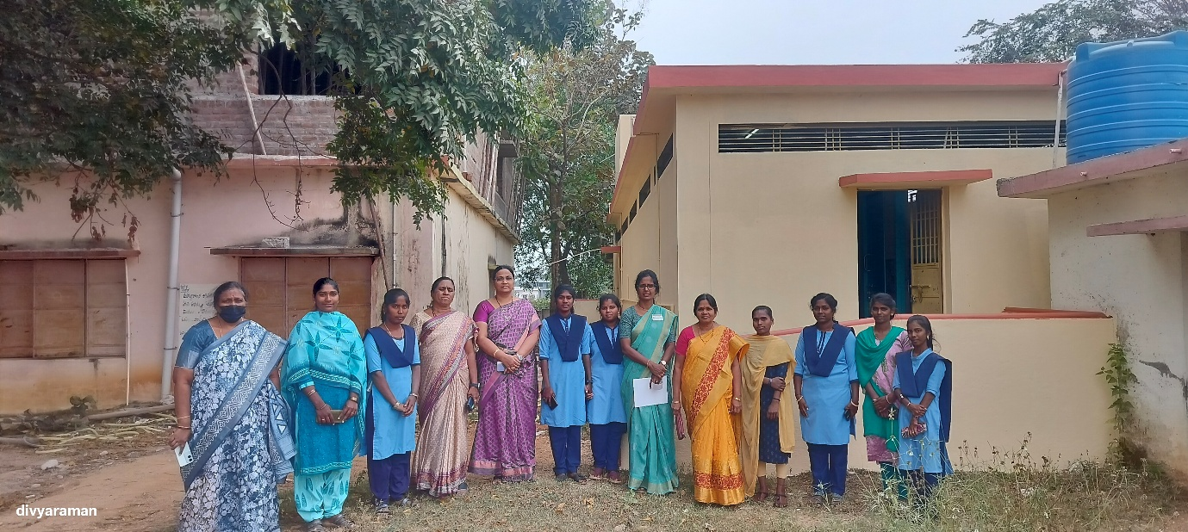
Training the girls to maintenance of waste of sanitary pads in proper way. Checking sanitary fecilities at women restrooms.
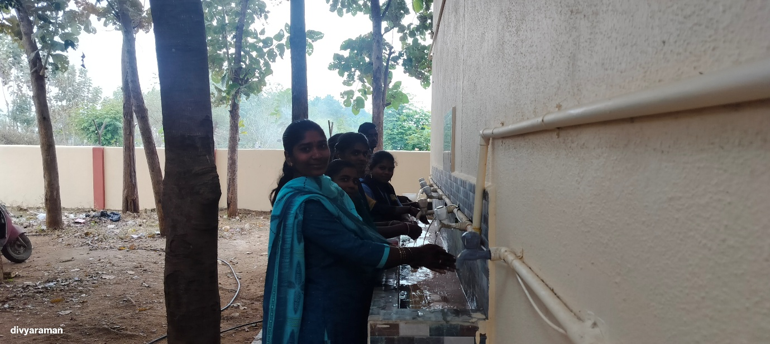
Wet waste management to the team.
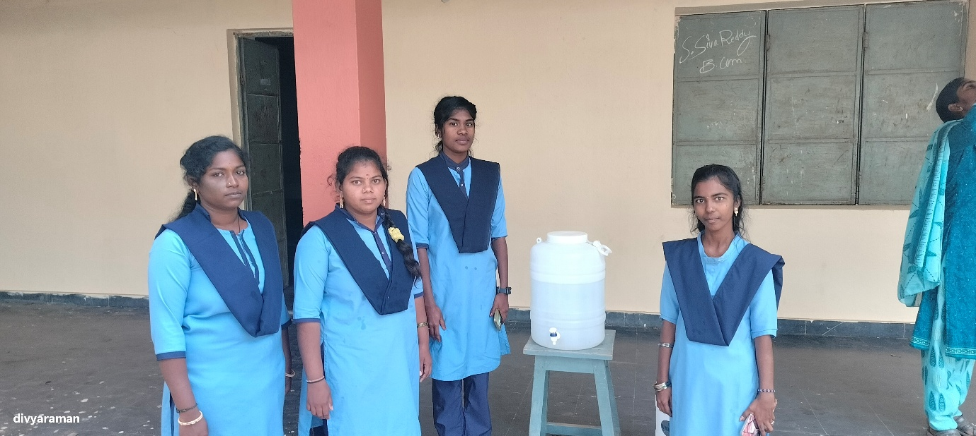
Fiber glass and plastic grasses wastage management.

